Team Control Number

For office use only

T1 ________________

T2 ________________

T3 ________________

T4 ________________

15210

Problem Chosen

For office use only

F1 ________________

F2 ________________

F3 ________________

F4 ________________

A

2012 Mathematical Contest in Modeling (MCM) Summary Sheet

(Attach a copy of this page to each copy of your solution paper.)

The major task to solve this problem is to find the possible correlation between characteristic of

the leaf (shape, weight, distribution, etc.) and the size of the tree (height, mass, volume, etc.). To

accomplish the task, we make three preparations and assumptions:

Trees change their size characteristics to acquire more sunshine by evolution.

Define Exposure Ratio to quantify the utilization of sunshine.

Find six common leaf shapes and model them into analytical expressions.

On the basis of these preparations, we make four models for the trees consisted of branches and

leaves: the Simple Model, the Leaf-enhanced Model (LeM), the Pyramidal Model (PyM), and the

Paramount Model (PaM). In the Simple Model, each parent branch only bifurcates into two child

branches symmetrically and leaves can only grow in the bifurcating node. We then develop this

model to LeM by mending the growth rule of the leaves. The simulation reveals that the LeM can

realistically model one common kind of the tree in the nature world. Furthermore, we change the

rule of the branch growth to make PyM. Together with LeM, it can model almost all the common

trees in the world. Moreover, we make PaM using Markov Chain to model trees more precisely.

With the help of the models, we create the optimal tree for each kind of leaves by the criterion of

Exposure Ratio. Because of the allowed randomness of some parameter, such as the number of

leaves at a node, we test every input for ten times and average the results. To calculate the volume

of the tree, we surface fit the terminal points of the last-level-branches by cubic interpolation.

Finally, we compare and analyze the size characteristics of these optimal trees to determine the

correlation of trees and leaves.

Team #15210

Page 2 of 28

A realistic model for trees growing

towards sunshine

Letter to the editor

Our goal is to find the relationship between the leaf shape and tree profile then to go one step

further to catch the correlation between the leaf mass and tree size. We consider maximizing

exposure as the major factor to determine the leave shape. We construct six typical leaf shapes and

two common branching patterns to make four models for tree structure. Branch angle and its

furcation style is the variable to control our tree profile. With computer simulation, we select the

best shape with the maximal exposure area for each type of leaves, which pave the way to detect

the correlation between the leaf mass and tree size. Our results are as follows.

To begin with, we find that leaf shape would influence the tree profile. The simulation reveals that

trees with needle and ovate leaf tend to have a pyramidal shape, while the tree with round or

cordate leaf prefers V-shaped profile. Generalizing the results, we conclude that the tree with “thin”

leaves will be willing to grow into a similar “thin” shape. While the tree with broader leaves

inclines to have a wider profile with smaller branching angles.

In addition, we can calculate the total leaf mass, tree height, tree mass, and its volume since the

tree structure was settled for each different leaf according to our previous simulation. The number

of leaves varies from shape to shape, and the average number is about 1700 for pyramidal tree,

and 1400 for V-shaped tree. At the same time the tree mass is also fluctuant and the average is

around 540kg for pyramidal tree and 950kg for V-shaped tree. The correlation is more obvious in

our third model that the tree with less leaves (thus with less leaf mass) also has a smaller height,

less branch number and lighter tree mass. Therefore, leaf mass is positively correlation to the size

of the tree.

However, there is no obvious relationship in our result obtained from our second model. The

reasons are complex. On one hand, leaf mass is not simply positively related to leaf number for

differences in species and environmental factors would largely change the leaf density and

thickness. On the other, tree mass and its volume is related to branching pattern. Though this

pattern is influenced by leaf shape, many other environmental factors involves in this system.

Team #15210

Page 3 of 28

Summary

The major task to solve this problem is to find the possible correlation between characteristic of

the leaf (shape, weight, distribution, etc.) and the size of the tree (height, mass, volume, etc.). To

accomplish the task, we make three preparations and assumptions:

Trees change their size characteristics to acquire more sunshine by evolution.

Define Exposure Ratio to quantify the utilization of sunshine.

Find six common leaf shapes and model them into analytical expressions.

On the basis of these preparations, we make four models for the trees consisted of branches and

leaves: the Simple Model, the Leaf-enhanced Model (LeM), the Pyramidal Model (PyM), and the

Paramount Model (PaM). In the Simple Model, each parent branch only bifurcates into two child

branches symmetrically and leaves can only grow in the bifurcating node. We then develop this

model to LeM by mending the growth rule of the leaves. The simulation reveals that the LeM can

realistically model one common kind of the tree in the nature world. Furthermore, we change the

rule of the branch growth to make PyM. Together with LeM, it can model almost all the common

trees in the world. Moreover, we make PaM using Markov Chain to model trees more precisely.

With the help of the models, we create the optimal tree for each kind of leaves by the criterion of

Exposure Ratio. Because of the allowed randomness of some parameter, such as the number of

leaves at a node, we test every input for ten times and average the results. To calculate the volume

of the tree, we surface fit the terminal points of the last-level-branches by cubic interpolation.

Finally, we compare and analyze the size characteristics of these optimal trees to determine the

correlation of trees and leaves.

Introduction

We are intended to discuss the relationship between the shape of leaves and size of tree. Then

calculate the rough number and mass of leaves. First of all, the structure of a tree is determined by

its branching pattern.

After millions’ years’ evolution, trees must have chosen the best scheme to maximize the

efficiency of absorbing sunshine, water and many other things. We make several reasonable

assumptions on the law of branch growth. Moreover, we focus on six common shapes of leaves.

Our model develops as follows:

Step 1 Simple Model

In simple model we will simplify the structure of tree in order to get a preliminary result of

the relationship between shape of leaves and tree. All variables are fixed except the angle of

bifurcation. This model gives an optimal angle of bifurcation which enables the tree to have

the greatest exposure ratio.

Step 2 Leaf-enhanced Model

Team #15210

Page 4 of 28

In Leaf-enhanced model we will change the growth pattern of leaves to meet the natural way.

With changed condition we again use the same algorithm to get an optimal angle.

Step 3 Pyramidal Model

In Pyramid model we will change the law of bifurcation. Previous two models give us a

V-shaped profile of tree, which is one of many tree structures. We add another furcation

pattern to make the tree look like a narrow pyramid. Then we will find the optimal angle

under this condition.

Step 4 Paramount Model

In Paramount model we will further revise the furcation pattern and growth pattern of leaves.

This model will perfectly correspond with reality.

After the four steps above we can achieve enough convincing evidence and be able to draw a final

conclusion concerning the relationship between the shape of leaves and tree.

Why do leaves have various shapes

As far as we know, several factors work on together to determine the shape of leaves by the

process of evolution, such as the absorption of sunshine, water and CO2. It is leaves’ function to

absorb CO2 and light for photosynthesis to provide other parts of the tree with enough glucose,

and leaves should also be designed to prevent water from escaping plant.

We take into consideration the effect of sunshine as the decisive factor of the tree structure.

The exposure ratio of different leaf shape

We set exposure ratio to quantify the utilization of sunshine which is calculated by the following

formula.

∑

area of utilized sunshine

Exposure Ratio=

every leaf

∑

area of leaf

everyleaf

Definition

We call a branch ‘parent branch’, if it furcates into two or more parts, which share similar size,

and we call these parts the ‘child branch’ of their parent branch. This behavior is called ‘main

bifurcation’.

Now we give the definition of branch level. The main trunk of the tree, which is the parent branch

of all the other branches in the tree, is the 1st level branch. We then define nth level branch as the

child branch of (n-1)th level branch. With the help of mathematical induction, we give every

branch a level number. Some research pointed out that the sum of areas of every child branch is

Team #15210

Page 5 of 28

approximately equal to the diameter of their parent branch [C.Eloy].

Besides the “main bifurcation”, branch also grows in another way, which is “lateral branching”.

Branch can bifurcate into a small child branch and a main branch which has similar diameter with

its parent branch. We treat the big child branch as the same level of its parent branch. The level of

the small child branch, however, will not be accurately determined. We only assume that the level

small child branch is larger than N+3 when the parent branch is N. The precise level is decided

randomly in simulation program mentioned in next few chapters.

Assumption

Branches

We assume that each child branch shares the same diameter, and we stop the procedure of

furcation when the branch’s diameter is less than 1cm.

The branch cannot grow downward.

Leaves

Leaves grow at the place where nth branch bifurcate into (n+1)th branches.

Leaves also grow at the terminal branches of the tree.

In the simple model, we only consider the first condition, and we will add the second condition

into an improved model and make some assumptions.

All the leaves are in the same plain which is parallel with the ground.

The angle of the sunshine and the ground is 90 degrees.

Name

l

h

θ

Exposure ratio

Meaning

The width of leaf

The height of leaf

Bifurcate angle

Exposure ratio

Value/Formula

6cm

depend on style

randomly generated by computer

mentioned

Table 1. Variables used in our model

The Simple model

We now consider the sunshine as the only factor that determines the shape of leaves. Based on the



Team #15210

Page 6 of 28

discussion in previous chapter, we add some details in following assumptions.

Assumptions of the Model

In this basic model, lateral branching does not exist. The only bifurcation is ‘main

bifurcation’, and each parent branch only bifurcates into two child branches. Meanwhile,

these three branches fall into the same plane, and the angles between each child branch and

parent branch as well as each child branch’s length are the same (1=2 and l1  l2 ).

1 

2

We also set a fixed ratio between the length of child branch and parent branch.

In this model, this ratio is 0.9.

l1

l3

l2

Leaves grow averagely around the node for bifurcation. Graph 2 gives two examples where *n*

denotes the number of leaves.

The initial angle of the leaves is 0 (*θ*1*=*0, Graph 1).

θ1

Graph 1. Illustration of θ1

n=3

n=4

Graph 2. Leaves at one node

In this model, we introduce five different leaf shapes listed in the following blanket.

Shape

Ovate

Round

Cordate

Digitate

Flabellate

Image

Table 2. Different shapes of leaves

We do not calculate the sum of exposure area leaf by leaf because of its great complexity. Instead,

we calculate it integrally. We divide the ground into small squares with length 4mm. We then

choose the center point of each square as the marking point of this square. If this point is covered

by leaf (we don’t care how many leaves cover the point), we then believe that the whole little

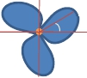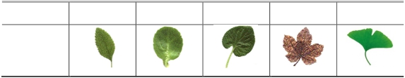

Team #15210

Page 7 of 28

square is covered by leaf. After calculating all the squares on the ground, we get the sum of

approximate exposure area of all leaves.

How to judge whether a point is covered by leaf is a difficult task. We have to first turn these leaf

shapes into mathematical model. We discuss them one by one.

Ovate /Needle. We treat the ovate shape approximately as an ellipse. Supposing the length of

the major axis is *l* and the minor axis is *h*, we then get the expression of ellipse.

y

h

O

l/3

l

x

Graph 3. Ellipse

Point *O* is the growth point on branch, and the *l/3* is the length of petiole of leaf. The

expression is

5

6

2

4 4

Upon most instances, we suppose *h*=*l*/2, but in the Pyramidal model mentioned in following

chapters, we suppose *h*=*l*/10.

Round. The only difference between round shape and oval shape is that the length of minor

axis and major axis is just the same.

y

l

O

l/3

l

x

Graph 4. Circle

The expression of this shape is

5 l 2

6 4

Cordate. To discuss the mathematical expression of cordate, we use polar coordinate.

The polar coordinate expression of cordate is r  1 (1  cos ) (as shown below from the

2

coordinate chart *xO'y'*)

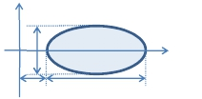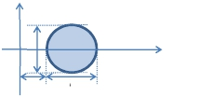

（x − l) 2

y 2

 2  1

l h

(x − l)2  y 2

Team #15210

y'

y

Page 8 of 28

O’

l/8

O

l

x

Graph 5. Cordate

We then transform the polar coordinate into rectangular coordinate, we get formula of the

boundary of cordate leaf as the following, and change the *x* with *x−l/3*, we can get the correct

expression of cordate.

y1 

2x

8x

l

1 −

( 1 

8x

l

4

−1)2

y2 

2x

8x

l

1 −

( 1 

8x

l

4

1)2

(only exist when *x*<0)

Digitate. We separate the boundary of digitate into six parts. Digitate leaf is symmetrical, so

we only consider the part beyond x axis.

y

O

l/2

l/3

l

l/6

x

Graph 6. Digitate

Here we lengthen the length of petiole to *l*/2. We assume that each part of the boundary is

part of circle. We are then able to write the formula of boundary in form of piecewise

function.

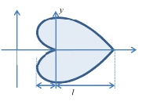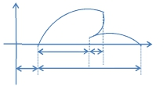

1    −1

− 1    −1

Team #15210

y 

y1 

y2 

y3 

y 

1 2 2 1 5

4 2 6



l − (x − l) 

4

l  (x − l)  x ∈[ l, l)

12 l 6 6

1 3

96 2 

1 3 3

96 2 2

Page 9 of 28

Flabellate. We ignore the small notch on the leaf, and simply assume the shape as a sector.

y

60°

O

l

l

x

Graph 7. Flabellate

The formula is easily calculated as follow:

2 1

2

1

2

In the following models, we will use the formulas deduced before to describe every shape.

The algorithm for the computer simulation

We have abstracted the five different kinds of leaves into five analytical expressions. However,

because the shadow of thousands of leaves would overlap, it is still hand to analytically express

the area of the shadow. In order to solve the problem quickly and precisely, we make four

optimizing algorithms to accelerate the process.

①Divide the basic leaves to small squares. The size of the square is 0.004m*0.004m in order to

minimize the computational mistake within the computing capability. Then we draw a point in the

center of every square. Recode the coordinates of the points before the simulation as

preprocessing. The following graph shows this process.

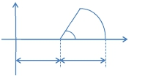

l − (x − l) , x ∈[ l, l)

1 2 2



1 15 5 2  5





(x − l)



(x − l), x ∈[l, l]

y  l 2 − (x − d ) , x ∈ (d  l, d  l]

y  3(x − d ), x ∈[d, d  l]

Team #15210

y'

y

Page 10 of 28

O’

l/3

O

l

x

Graph 8. Points on the leaves

②We also divide the ground into the same small squares. When the center of one square is

covered by the shadow, we mark the point as “true” for shadowed.

③When we want to calculate the shadow of a particular leave in the tree ( For example, a leave

which direction is *θ* and position is ( ,

) ), we could simply use the preprocessed leave points

(x ,y) and do the following simple matrix operations:

′

"

′

(x” ,y”) is the leave points we want in the tree. We can calculate every point in the prepossessed

leave.

④ Because the process to handle each branch is similar, we use recursion to process the branch

and stop the calculation at a certain level of the branch. (E.g. max level=6)

Result of Simulation

We put the information of five different kinds of leaf into our program, and the simulation result is

shown below.

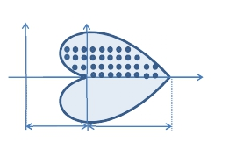

′

"

′

Team #15210

Page 11 of 28

Legend:

round

ovate

cordate

flabellate

digitate

bifurcate angle(in radian)

Graph 9. The bifurcate angle-exposure ratio graph (n=3)

From the result we know that the optimal bifurcation angle that has the most exposure ratio differs

when shape of leaf changes. The optimal angles for each shape are listed below:

shape

angle(radian)

angle(degree)

exposure ratio

round

0.29

16.6

0.640

ovate

0.26

14.9

0.603

cordate

0.52

29.8

0.550

flabellate

0.50

28.7

0.580

digitate

0.35

20.1

0.578

number of leaves

363

Table 3. Optimal angle for different shapes (n=3)

When *n=*6, the angle-ratio graph changes into another type.

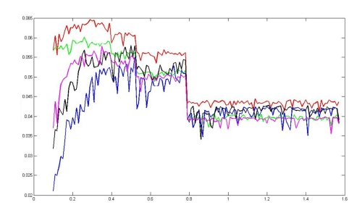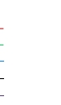

exposure ratio/10

Team #15210

Page 12 of 28

Legend:

round

ovate

cordate

flabellate

digitate

bifurcate angle(in radian)

Graph 10. The bifurcate angle-exposure ratio graph (n=6)

The optimal angles for each shape are listed below:

shape

angle(radian)

angle(degree)

exposure ratio

round

0.30

17.2

0.490

ovate

0.24

13.8

0.586

cordate

0.68

39.0

0.351

flabellate

0.39

22.4

0.553

digitate

0.36

20.6

0.540

number of leaves

Table 4.

726

Optimal angle for different shape(n=6)

We have to mention that the number of leaves is an average number during simulation. The shape

of leaf has nothing to do with the number because the way leaves grow doesn’t change.

From the discussion above, we can then draw some conclusions:

When n is 3, round shape seems to have superiority over other shapes. It is easily explained

because leaves with round shape nearly do not cover each other and have a larger covering

area. However, ovate shape performs better than other shape when n is 6, because ovate

leaves share a comparatively smaller overlap area. This increases the total exposure ratio of

the tree.

The angle of these shapes varies from 15°to 40°, which perfectly meets the reality.

From the simulation we get a series of different trees. The pictures are shown as followed. The trees

shown below look like real ones, and their shapes differ from each other markedly. This strengthens the

opinion that tree shape does influence the leaf shape.

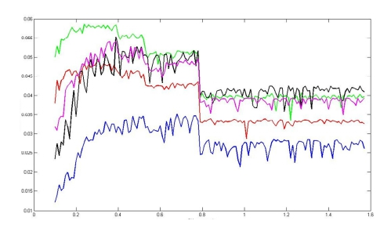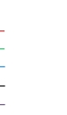

exposure ratio/10

Team #15210

Page 13 of 28

round

heart

flabellate

ovate

digitate

Graph 11. Optimal tree of different leave shapes (n=6)

Leaf-enhanced Model

Improvements

In leaf-enhanced model, we change the way leaves grow. Leaves not only grow at the furcation

point but also on the branch of last level. In this model, each branch of last level has four nodes

which are uniformly distributed, and leaves grow at each nodes as well as the terminal point. The

number of leaves is randomly settled between 2 and 6, and the angle between leaf stalk and x axis

is also randomly generated, that is to say, the *θ*1 is randomly generated.

Node

Terminal point

Graph 12. Branch of last level

θ1

Graph 13. Illustration of new model

This modification makes our model more similar to reality because we allow leaves to grow on the

thinnest branch, which is the same as trees in our lives.

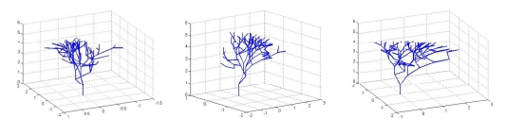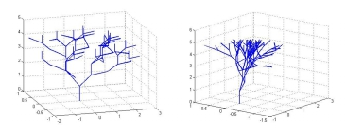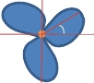

Team #15210

Page 14 of 28

Graph 14. Flowchart of the L model

Result of Simulation

We also use the five kinds of leaf shape mentioned before in this model. Simulation outcome is

drawn as figure in the next graph.

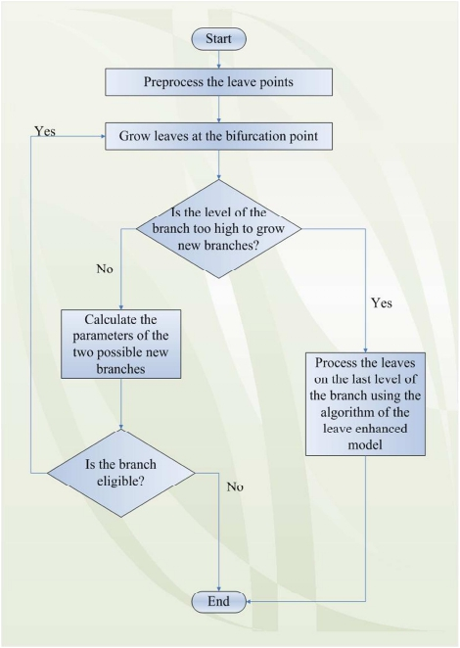

Team #15210

Page 15 of 28

Legend:

round

ovate

cordate

flabellate

digitate

Graph 15. The bifurcate angle-exposure ratio graph (n=3)

Legend:

round

ovate

cordate

flabellate

digitate

Graph 16. The bifurcate angle-exposure ratio graph (n=6)

The optimal bifurcate angle and corresponding exposure ratio of every leaf shape are shown in the

following table.

shape

angle(radian)

angle(degree)

exposure ratio

round

0.39

22.4

0.557

ovate

0.37

21.2

0.535

cordate

0.73

41.8

0.331

flabellate

0.51

29.2

0.450

digitate

0.38

21.8

0.469

number of leaves

1062

Table 5. Optimal angle for different shape(n=3)

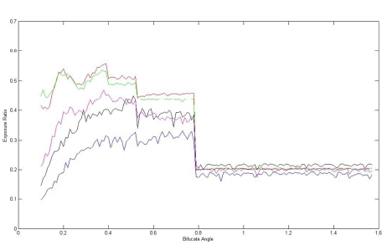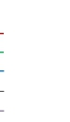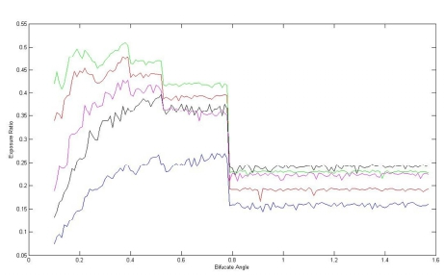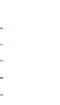

Team #15210

Page 16 of 28

shape

angle(radian)

angle(degree)

exposure ratio

round

0.39

22.4

0.490

ovate

0.38

21.8

0.586

Cordate

0.77

44.1

0.351

flabellate

0.52

29.8

0.553

digitate

0.37

21.2

0.540

number of leaves

1404

Table 6. Optimal angle for different shape(n=6)

By comparing these data to the results we get from previous model, we can find some obvious

differences:

The angle is much larger than the result in simple model, no matter what the shape of leaf is.

It can be easily explained because a smaller bifurcate angle will lead to an increased

overlapping between leaves on the top of tree. Meanwhile, most leaves are grown on these

‘terminal branches’. These two facts work together to contribute to the increase in optimal

angle. Obviously, the angle shouldn’t be too big to minimize the interstice between leafs. By

the way, we have to make an important point concerning leaf number clear. The leaf number

is 1404 when *n*=6, while the number is 1062 when *n*=3. The first number is not precisely two

times as the second number because *n* only works on the branches except the last level.

The exposure ratio is a little bit smaller than the result in simple model. Generally speaking,

they drop about 10 percent. This is because the great increase in the number of leaves. We

can learn from the result that the number of leaves increase to two times as the simple model.

There is little difference in optimal angle between *n=*3 and *n=*6, no matter what the shape of

leaf is. It is because we set six growth points for leaves at the last level of branch, and the

angle of each leave is randomly generated. As a result, the overlap between leaves on the

same branch contributes most of the overlap area, which result in the phenomenon that the

optimal angle has little to do with *n*.

The trees with optimal angle of each shape are drawn in the next graph.



Team #15210

Page 17 of 28

round

heart

flabellate

ovate

digitate

Graph 17. Optimal tree of different leave shape(n=6)

Graph 19 offers us a picture of Maidenhair tree. Their similarity suggests the accuracy of Leave

enhanced Model.

Graph 18. Maidenhair tree[http://www.user.jqw.com/]

Pyramidal Model

Improvements

From the previous result we find that trees set up by our assumptions are mostly in the shape of

inverted pyramid. Some species of tree do not possess this shape, such as sequoia. In order to

examine the relationship of leaf in this tree, we then revise the growth pattern of branch to make

our tree more like a pyramid.

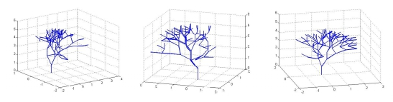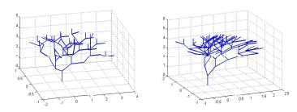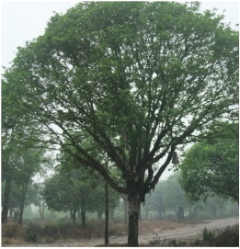

Team #15210

Page 18 of 28

In this model, the branch’s growing place and level is determined by the following steps:

Step 1 Let *N* denote the level of main trunk. We firstly initialize *N* as 1. Let *d* denote the

distance on the trunk from ground. We firstly initialize *d* as 3m. *d*N is a number determined by

the following formula:

d1  1.5

d n  d n−1 ⋅ 0.9

Step 2 Pick a random number *R* ranges in 1,2 or 3.

Step 3 Pick a random number *ψ* ranges between 0 and 360.

Step 4 If *R*=1, a new branch will grow at *d*N which forms an angle *ψ* with zero line.

branch

ψ

trunk

zero line

Graph 19. Illustration of ψ

Step 5 If *R*=2, a new branch will grow the position dN and forms an angle *ψ* with zero line.

Another branch will also grow at the same position but forms an angle *ψ*+180° with zero line.

Step 6 If *R*=3, a new branch will grow the position *d*N and forms an angle *ψ* with zero line.

The second branch will also grow at the same position but forms an angle *ψ*+120° with zero

line. The third branch will grow at the same position but forms an angle *ψ*+240° with zero

line.

Step 7 *N=*N+1, *d=d+ d*N

Step 8 If N ≤ 6 (we assume that the storey number of the tree is six), go back to Step 2

The law mentioned above is only suitable for the growth of branch directly linked to trunk, while

other branches grow in the same way as the previous model. The purpose of this model is to

search the optimal angle between lateral branch and trunk. As a result, for each leaf shape we fix

the angle between lateral branches as the optimal angle achieved in Leaf-enhanced model.

We also add a new style of leaf: needle shape. The needle shape is derived from ovate shape, and

the only difference between the two shapes is *l*/*h*. The *l*/*h* in the needle shape is 10, while the *l*/*h* in

the ovate shape is 2.

Result of Simulation

The angle we get here is the one between lateral branch and main trunk.

shape

angle(radian)

round

1.52

ovate

1.55

cordate

1.53

flabellate

1.43

digitate

1.54

needle

1.37



Team #15210

Page 19 of 28

angle(degree)

exposure ratio

leaf number

87.1

0.6239

1893

88.9

0.6619

1598

87.7

0.3104

1723

82.0

0.5026

1679

88.3

0.5555

1519

78.5

0.6527

2344

Table 7. Optimal angle for different shapes (n=6)

From the data we can learn that the branches grow from main trunk are nearly perpendicular to trunk.

This angle can help the branch to spread as far as possible for extra are and more sunshine.

Furthermore, on exposure ratio, needle and ovate shows great advantage in the competition with other

four shapes. The fact strengthens the opinion that needle-like leaf greatly improves the efficiency of

sunshine absorption. This perfectly meets the fact that most pyramid-like tree has the leaf shaped in

narrow oval, or needle. The two graphs shown below further express this advantage.

Legend:

round

ovate

cordate

flabellate

digitate

needle

Graph 20. The bifurcate angle-exposure ratio graph (n=3)

Legend:

round

ovate

cordate

flabellate

digitate

needle

Graph 21. The bifurcate angle-exposure ratio graph (n=6)

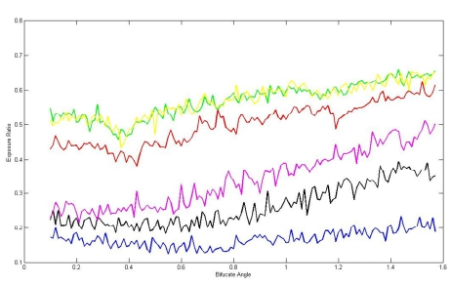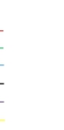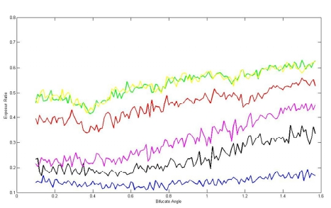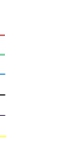

Team #15210

Page 20 of 28

We can also learn from the result that the exposure ratio increased by about 10 to 20 percent

compared with Leaf-enhanced Model, which means that pyramid-like tree has superiority in

absorbing sunshine. The reason why the pyramid-like tree is not so widely spread as inverted-

pyramid-like tree is that it’s difficult for lateral branch to support weight on branch because of big

bifurcation angle. As a result, on most occasions the lateral branch grows in a short length to avoid

possible break.

round

flabellate

ovate

digitate

cordate

needle

Graph 22. Optimal tree of different leave shape(n=6)

Graph 17 gives us six optimal trees for each leaf shape and Graph 18 offers us a picture of real pine.

Their similarity suggests the accuracy of Pyramidal Model.

Graph 23. Yingke Song in Mount Huang, Anhui, China

Paramount Model

On our way approaching the natural way in which tree branches grow, we adopt a more complex

rule. Since it is a discrete event that each shoot develop from its parent branch, branching pattern

could be simulated by Markov process. Denote as the distance between the nodes of a child

branch and its parent branch.

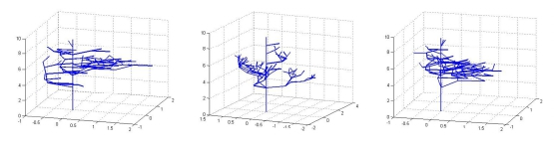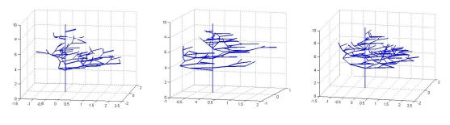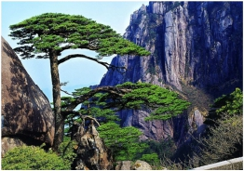

is the level of a branch according to the definition before.

Team #15210

Page 21 of 28

(

,

) is the state of Markov Chain. Denote Q, a mn×mn matrix as the transition probability

matrix. The state of a child branch is only related to the state of its parent and is independent to

other previous branches. Λ is a set of natural number which is the range of n, the number of child

branches each parent branch has. Every state *x*nm is related to a certain *k*i and P(*k*i=*j*|*k*nm)=*P*nj, *j*∈ Λ,

=1. Considered the practical situation, can only take value in a certain range which is

limited by the length of parent branch,

would not be too large which is determined by the

furcation capacity of a branch, is related to the level of a branch. Therefore, we have

.

After construct the position of every branch, we set the angle of each branch as before to obtain

the final branch structure.

The Estimation of Leaf Mass

First of all we briefly summarize what we have done before. We are intended to find the

relationship between the shape of leaf and tree, and we explore it by controlling variables method.

The goal of our simulation is to find the structure to maximize the exposure ratio. We set the angle

of bifurcation as variable to control the shape of tree. The simple and leaf-enhanced model focuses

on the V-shaped tree, and the pyramidal model focuses on the pyramid-like tree. From the

simulation we have got optimal angle of every possible way of branch growth, and we are going to

use the data to estimate the mass of leaves and tree.

We must note that the mass of a single leaf varies greatly from tree to tree. Many factors

contribute to the difference and we only take two of them into consideration.

Water preservation. When trees grow in arid area, it’s harder for leaves to preserve water

from evaporation. As a result, leaves should reduce their superficial area as much as possible,

which leads to an extreme shape of leaf: needle. The cactus living in desert shares this

specially made leaf.

Heat preservation. It’s a problem for leaves to preserve heat when they live in a cold climate.

Leaves have to develop a thick protection layer of wax to prevent heat from escaping the

body. The protection layer also stops water from evaporating.

To estimate the leaf mass of a tree, we need to know the mass of a single leaf and the total number

of leaves in a tree. Firstly, we consider estimating the former. An assumption was made in the

model we discussed before that the leaves are two dimensions without thickness (midway between

the margin and midrib at the widest part of the leaf), which is less desirable to calculate the leaf

mass. It is well known that higher light irradiances and lower nutrient or moisture would make the

leaf thicker. In addition, leaf density and thickness often vary independently with leaf position in a

plant. Thus, we introduce an index, leaf specific mass (LSM), which is the product of leaf density

and thickness, i.e.

LSM= density × thickness =

mass ×thickness = mass

volumn area

Considered the special shape, for needle-shaped leaves, the formula becomes:

LSM = 0.7854 × density × thickness

The thickness is determined by the diameter of pine needle. LSM varies in accordance to the

∑

constructed a Markov progress, after determine m, the transition probability matrix Q, Λ,

Team #15210

Page 22 of 28

moisture, light and other environmental conditions as well as the tree species. Here, according to

the several types of the tree we modeled, we set LSM=200µg/mm2. Then calculate the leaf area to

obtain single leaf mass. Finally, we get the leaf mass by multiply single leaf mass and total leaf

number in a tree.

Estimation of Leaf Area

We use the data of leaves mentioned in the simple model to calculate the area of each leaf. We will

calculate these areas one by one.

First let *l* mentioned in chapter ‘The Simple Model’ be 6cm. The area of round shape can be

immediately got by formula

2 2

2 2

 2   2 

The area of flabellate shape is given by

1 1 1 2 2 2

3 3 3

We can simply get the area of ovate shape by a compressing a circle into an ellipse, the formula is

shown below:

s  ⇨ lh  ⇨

l l

2 4

2 2

Needle shape is a ‘flattened ellipse’. The area formula is the same:

s  ⇨ lh  ⇨

l l

2 10

2 2

When the problem comes to cordate shape, we have to refer to its polar coordinate expression. The

polar coordinate expression of cordate-shaped leaf is:

r 

l

2

(1  cos  )

The x-axis divides the ‘heart’ into two equal-sized parts. We only have to calculate the area of one

part. By integrate the variable *θ*, we have:

⇨

0

⇨

0

l 2

4

2

⇨

0

⇨ 3 1

0

3 2 27

2 2

2

The shape digitate is the most difficult, and it’s hard for us to directly integrate the formula.

Instead we integrate it numerically by computer. The result is 15.0 cm2. We then conclude these

results in the following table.

 l   6 

s  ⇨ r 2  ⇨    3.14    (cm )  28.26(cm )

s  ⇨ r 2  ⇨ l 2   3.14  6 (cm )  37.68(cm )

⋅  3.14  3 1.5(cm )  14.13(cm )

⋅    3.14  3  0.3(cm )  2.826(cm )

s  4∫ r 2d

 4∫

1  cos  d

 l 2 ∫ (1  2cos  cos 2  )d

 l 2 ∫ (  cos 2 +2cos )d

2 2

 ⇨ l 

Team #15210

Page 23 of 28

Shape

2

Ovate

14.1

Round

28.3

Cordate

42.4

Digitate

15.0

Flabellate

37.7

Needle

2.83

Table 8. Area of different leaf shape

The Mass of Leaves

We now use the leaf number from Leaf-enhanced Model and Pyramidal Model to calculate leaf

mass of the corresponding tree style. We collect all the data we need in the next table.

Shape

Ovate

Round

Cordate

Digitate

Flabellate

Needle

Style

Area(cm2)

14.1

28.3

42.4

15.0

37.7

2.83

n=3,L model

n=6,L model

1062

1404

n=6,P model

1893

1598

1723

1679

1519

2344

Table 9. Data Collection

When the leaf shape is not needle, we suppose LSM=200µg/mm2 while LSM=0.7854 

200µg/mm2 when the leaf is needle-like. Then the total mass of a 5-meter tree are shown below:

Shape

Ovate

Round

Cordate

Digitate

Flabellate

Needle

Style

n=3,L model

n=6,L model

601092

794664

299484

395928

900576

1190592

800748

1058616

318600

421200

n=6,P model

1071438

450636

1461104

1265966

455700

104199.3

Table 10. Total Mass of Leaves(mg)

This gives a final result to the question of leaf mass of a tree.

Correlation between Leaf Mass and Size

Characteristics

We now turn to discover the relationship between leaf mass and the size characteristics of tree,

such as height, mass and volume defined by the profile. We now give precise definition of these

three characteristics.

The *height* of a tree is the distance between the bottom of trunk and the highest point of its

branch.

The *mass* of a tree is the sum of mass of all branches and main trunk.

The *volume* defined by the profile of the tree is somewhat complex. Firstly we call these

points ‘terminal points’, which are the terminal point of branches of last level. By surface

fitting of cubic interpolation, we gain a smooth surface Π which passes all the terminal points.

Then we project this surface onto the ground, and get a shadow named Π'. Let *z*min denotes

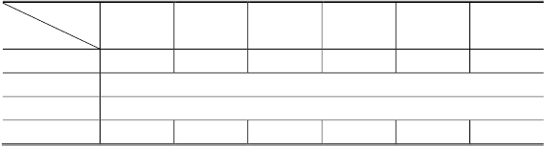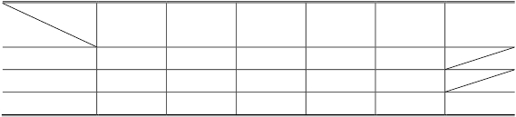

Area(cm )

Team #15210

Page 24 of 28

the terminal point whose z-coordinate is smallest, and ̅ denotes average z-coordinate of all

terminal points. We call the surface Π'' which is parallel to the ground with z-coordinate *z*min*.*

We then divide the volume into two separate parts, the crown part and the bottom part. The

crown part is beyond the surface Π'' and the bottom part is below the surface Π''. The volume

of crown part can be calculated by formula:

V1  (z − zmin ) ⋅ S

Meanwhile, the bottom part can be treated as an inverted cone and we can use this formula to

calculate the volume of bottom part:

1

3

Here *d* denotes the height from ground where the trunk starts to bifurcate. In our model we

usually assume *d*=1m.

The optimal tree and the surface fitting results are shown as follows.

Leaf-enhanced Model:

Ovate

Round

Cordate

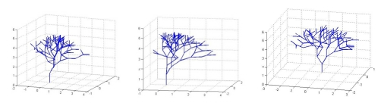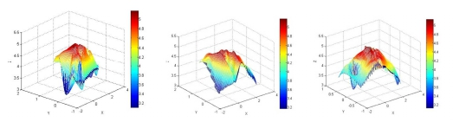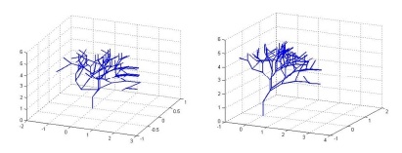

V2 min − d )

 S (z

Team #15210

Digitate

Pyramidal Model:

Flabellate

Page 25 of 28

Ovate

Digitate

Round

Flabellate

Cordate

Needle

*Branch volume* is the sum of the volume of all branches.

*Wood volume* is the sum of branch volume and trunk volume.

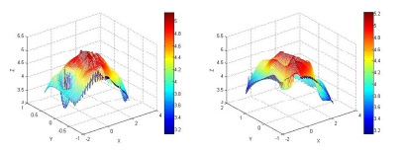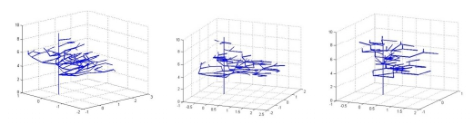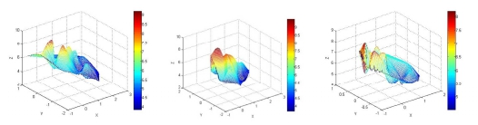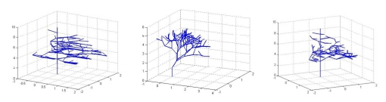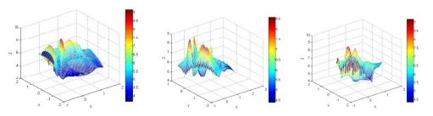

Team #15210

In this calculation, we suppose these variables as the following constant:

Page 26 of 28

Name

d

d1

d2

ρ

Meaning

diameter of trunk in Leaf-enhanced Model

diameter of the first level of branch in Pyramidal

Model

diameter of trunk in Pyramidal Model

density of branch and trunk

Value

60cm

20cm

50cm

0.65g/cm3[Van Noordwijk]

Table 11. Variable table 1

Then we give the calculation formula of several variables:

Name

VB

h

Meaning

Branch Volume

Height of Tree

Formula

Given by program(only in P Model)

Given by program

VW

Wood Volume

Given by program in L Model

2

3  2 

V0

M

Volume defined by profile

Tree Mass

Given by program

M=ρVW

Table 12. Variable table 2

With the help of computer, we get the height and volume of tree of both Leaf-enhanced Model and

Pyramidal Model (*r* mentioned in the table stands for the radius of main trunk) :

Shape

Round

Ovate

Cordate

Flabellate

Digitate

Size

Height(m)

3

5.0668

1.4553

Volume defined by profile(m3)

17.9712

17.1391

25.2303

22.3030

13.2240

Branch number

Leaf number

121

1404

Exposure ratio

0.490

0.586

0.351

0.553

0.540

3

0.9459

Table 13. Branch volume and Volume define by profile in Leaf-enhanced Model

Shape

Round

Ovate

Cordate

Flabellate

Digitate

Needle

Size

Height(m)

Branch Volume(m3,d1=20cm)

3

9.1426

0.2655

0.8639

9.1426

0.2924

0.8639

8.0244

0.1973

0.7225

8.4847

0.2194

0.7747

9.1426

0.2839

0.8823

9.1426

0.2842

0.8826

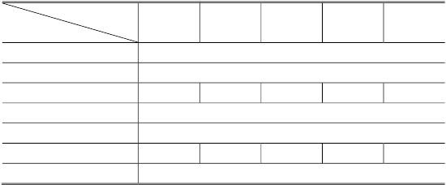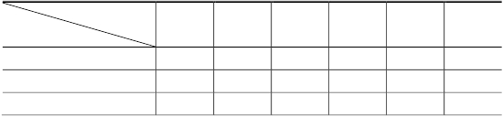

1  d 2 

VW  VB  ⇨   h in P Model

Wood volume(m ,d=60cm)

Tree Mass(10 kg)

Wood volume(m ,d2=50cm)

Team #15210

Page 27 of 28

Volume defined by profile(m3)

Branch number

Leaf number

Exposure ratio

Tree Mass(103kg)

22.4419

114

1888

0.6239

0.5615

25.6194

131

2190

0.6619

0.5615

15.9661

95

1562

0.3104

0.4696

22.7412

108

1790

0.5026

0.5036

23.7465

124

2034

0.5555

0.5735

21.4490

124

2045

0.6527

0.5737

Table 14. Branch volume and Volume define by profile in Pyramidal Model

The data except volume defined by profile are all the same in Table 12 because we only set the

bifurcate angle as variable. In fact, the volume defined by profile is greatly affected by the randomness

of bifurcate angle from the simulation result.

Conclusion

From the result above we can draw some conclusion about the shape of leaf and tree:

The needle and ovate shape leaf have a predominant advantage in pyramidal tree because

they enjoy the biggest exposure ratio. This also results in the large bifurcate angle. However,

the thin character of pyramidal tree results in a smaller amount of branch mass, which leads

to a smaller tree mass in total. We can then believe that the tree with thin leaves will be

willing to grow into a similar thin shape to increase the efficiency of sunlight absorption.

The round or cordate shape does not have much advantage when tree used to grow a large

cluster of leaves at one point while it behaves much better when there are fewer leaves at one

point. The branches tend to grow sparsely and the bifurcate angle is bigger when the tree

chooses round- or cordate-shaped leaves. This leads to a decline in the total number of

branches, then results in the decrease in the total mass of tree.

The flabellate and digitate shape seems to perform mediocrely in our simulation. However,

these two shapes do have some biological advantage, so many trees still choose these two

shapes as leaves.

With the help of computer simulation, we finally achieve an approximate result of leave mass and

tree mass. The number of leave varies from shape to shape, and the average number is about 1700

for pyramidal tree, and 1400 for V-shaped tree. At the same time the tree mass is also fluctuant and

the average is around 540kg for pyramidal tree and 950kg for V-shaped tree. The leaf shape has

major influence on the structure of branches, but the influence on tree mass is comparatively

trivial. The major influence on tree mass is the size of tree, which is determined by the age and

growth rate of tree.

Reference

[1] C. Eloy et al., 2011, *Leonardo's Formula Explains Why Trees Don't Splinter*, Phys. Rev.

Letters

[2] http://www.user.jqw.com/2010/06/09/268351/product/b201006171156485312.jpg

[3] XIA Ning, LI Bao-Guo, DENG Xi-Min, GUO Yan, 2004, *Modeling the Branching Patterns of*

*Peach Tree Branches (Prunus persica) After Being Pruned*, Acta Botanica Sinica,46 (7): 793-802



Team #15210

Page 28 of 28

[4] Van Noordwijk, M. and Mulia, R. 2002. *Functional branch analysis as tool for fractal scaling*

*above- and belowground trees for their additive and non-additive properties*. Ecological Modeling

149: 41-51.

[5] Thermo Fisher Scientific Inc.

*http://www.fishersci.com/ecomm/servlet/fsproductdetail_10652_695949_29101_-1_0*

[6] Spek, L Y and van Noordwijk, M., 1994. *Proximal root diameters as predictors of total root*

*system size for fractal branching models. II. Numerical model.* Plant and Soil 164: 119-128

[7] Byrne, Mary E, Epub 2011. Nov 11, *Making leaves Current opinion in plant biology*,

15(1): 24-30

[8] *http://www.user.jqw.com/2010/06/09/268351/product/b201006171156485312.jpg*